Sussex Safeguarding Adults Boards
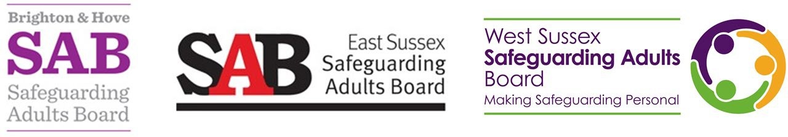

Adult death protocol

Initial joint agency meeting (IJAM) agenda

Item | Subject
1. | Welcome, introductions and apologies:  - Housekeeping  - Confidentiality and equal opportunities statement  - Recording of meeting if administration support is not available  - Statement of Professional Differences  - Purpose of meeting
2. | Background information on case:  - ADP Referral Form  - Pen picture of adult  - Chronology if available  - Nature of concern(s)  - Relevant historical information, including any known safeguarding concerns or enquiries  - Confirm criteria for adult death protocol met
3. | Initial information sharing and risk assessment, including risk to others
4. | Confirm lead agency and other agencies involved
5. | Consider other enquiry or investigatory processes, including:  - Section 42 safeguarding enquiry  - Section 47 child protection enquiry  - Serious Incident Process  - LeDeR  - Consider if criteria for a SAR are indicated
6. | Family considerations
7. | Agreed action plan with timescales
8. | Joint agency media strategy

9. | ADP Referral Form outcome section to be completed during the IJAM to include:  - If the criteria have been met/not met with reasoning  - Agreed outcome/actions  - Which agencies will take these forward  - Feedback to agencies/other parties
10. | AOB  - Including date of next meeting (if required) and chairing arrangements with lead agency

Statement of confidentiality and equal opportunities
All information discussed in this meeting is confidential. Organisations and individuals will aim to maintain the balance between the need for confidentiality and the sharing of information on a ‘need to know’ basis in the interests of safeguarding adults. In certain circumstances it may also be necessary to make information from the meeting available to third parties such as other professionals involved in the care and support of adults, and this will be recorded.
It is expected that all participants in the meeting will treat each other with respect, and that sensitivity to aspects of difference such as gender, disability, ethnicity, cultural and religious background is observed.
Any comments that contribute to discrimination are not acceptable and will be challenged by the Chair and other members of the meeting.

Statement of professional differences
‘It is acknowledged that when working in the arena of safeguarding, it is inevitable that from time to time there will be professional differences. This is a positive activity and a sign of good professional practice and effective multi-agency working. During this meeting practitioners, irrespective of their seniority are encouraged to say if they feel that decisions, practice, or actions do not effectively promote safeguarding or address objectives of this Adult Death Protocol.

